**Project Design Phase-I**

**Solution Architecture**

|  |  |
| --- | --- |
| Date | 19 September 2022 |
| Team ID | PNT2022TMIDxxxxxx |
| Project Name | Project - xxx |
| Maximum Marks | 4 Marks |

**Solution Architecture:**

Solution architecture is a complex process – with many sub-processes – that bridges the gap between business problems and technology solutions. Its goals are to

**Solution architecture:**

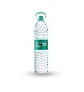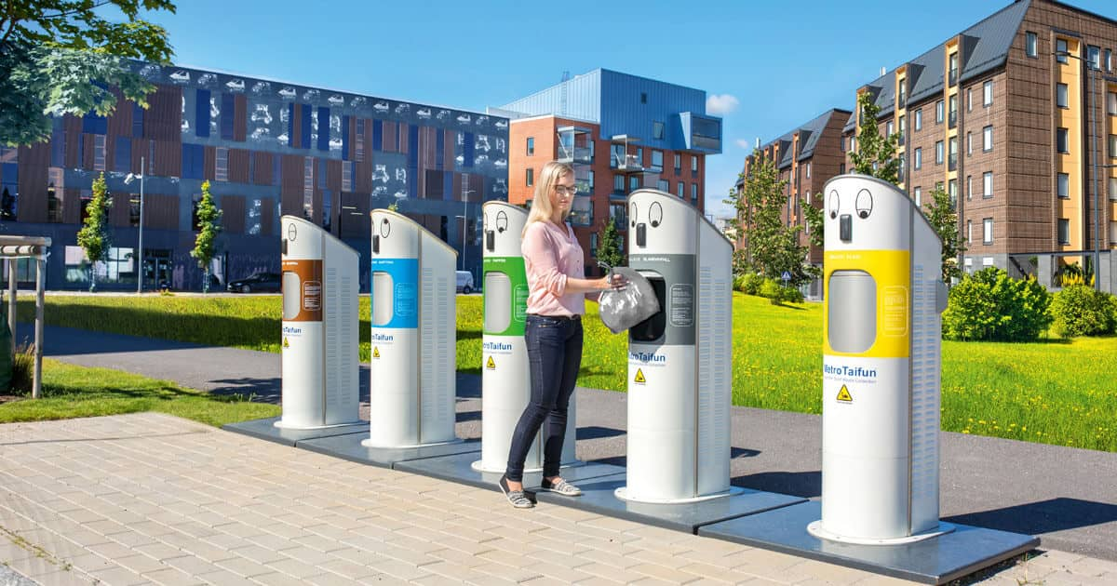

Amount will depends upon type of waste material(water bottle, drink bottle and chemical bottle)

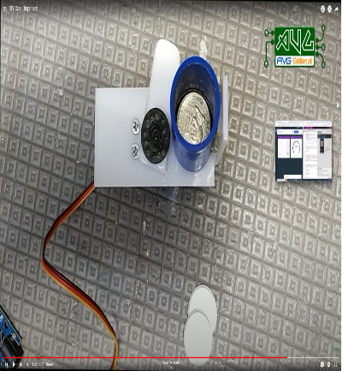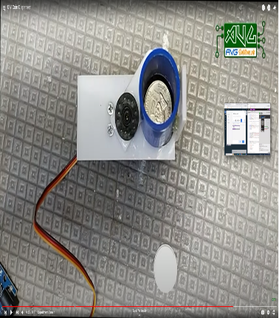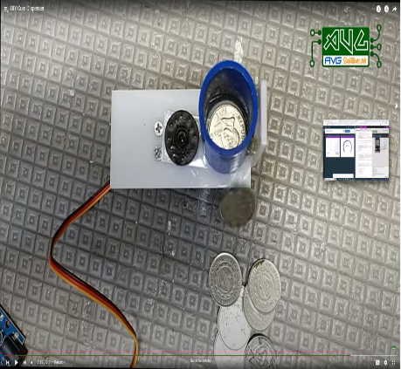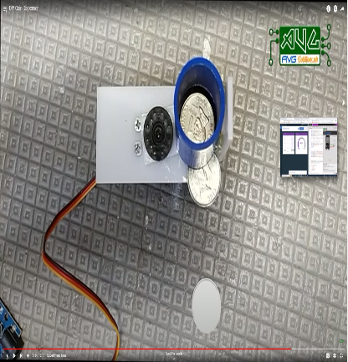

Cash will be received by people

If dustbin filled

